# **Optimizing User, Group, and Role Management with Access Control and Workflows**

**Team Leader:** Alfi James

**Team Members**: Swathi. A, Nithyaa Sri. S, Purvaja. S

## **Problem Statement:**

In a small project management team with a Project Manager (Alice) and a Team Member (Bob), there is a need to manage tasks efficiently and ensure accountability. Currently, there are no clear **role definitions**, **access controls**, or **structured workflows**, which leads to confusion in task assignments and makes it difficult to track progress.

## **Objective:**

**1. Define User Roles Clearly:**

* Assign specific responsibilities to Alice (Project Manager) and Bob (Team Member).
* Ensure clarity in permissions within the project management tool.

**2. Implement Access Control Mechanisms:**

* + Restrict Bob’s access to project creation and editing.
  + Allow Bob to only view and update assigned tasks.

**3. Streamline Workflow Processes:**

* + Create structured workflows for task assignment and tracking.
  + Enable Alice to assign tasks and monitor progress easily.

# **Skills:**

* Users
* Groups
* Roles
* Tables
* Access Control List
* Flow Designer

## **TASK INITIATION**

### **Milestone 1: Users**

#### **Activity 1: Create Users**

1. Open ServiceNow.
2. Go to **All → search “Users” → select Users under System Security**.
3. Click **New**, fill in user details, and submit.
4. 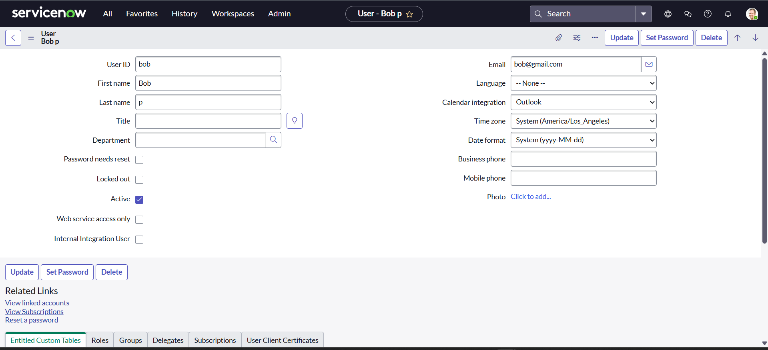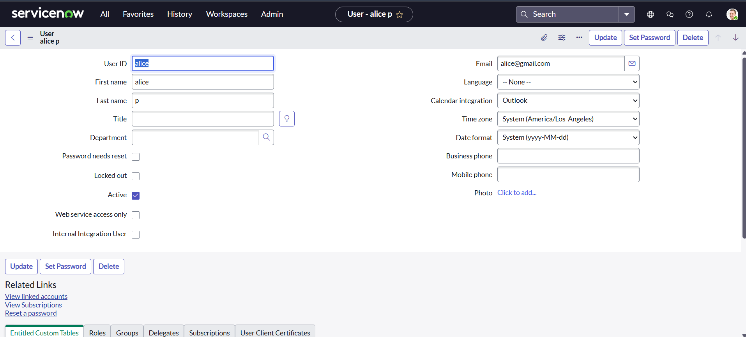Repeat the same process to create another user.

### **Milestone 2: Groups**

#### **Activity 1: Create Groups**

1. Open ServiceNow.
2. Go to **All → search “Groups” → select Groups under System Security**.
3. Click **New**, fill in group details, and submit.

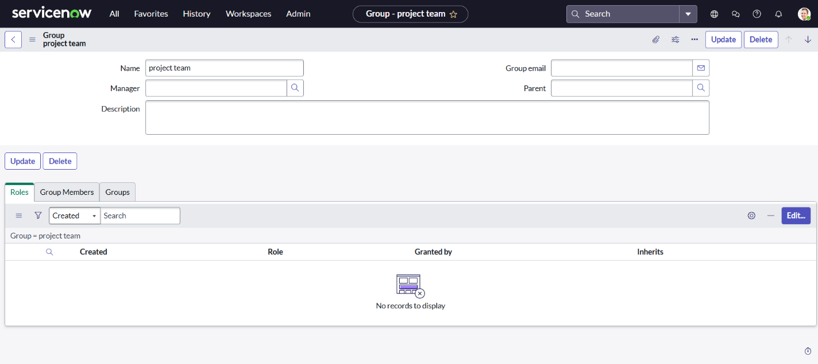

### **Milestone 3: Roles**

#### **Activity 1: Create roles**

1. Open ServiceNow.
2. Go to **All → search “Roles” → select Roles under System Security**.
3. Click **New**, enter role details, and submit.
4. Create another role by repeating the process.

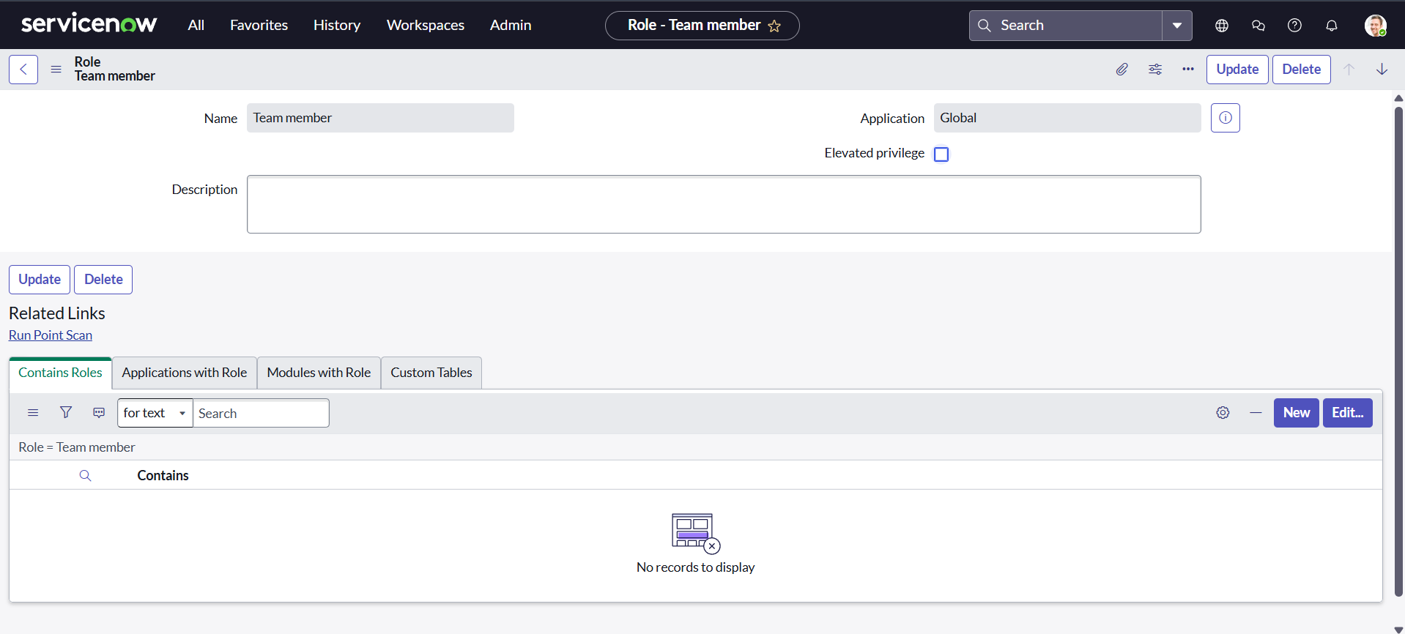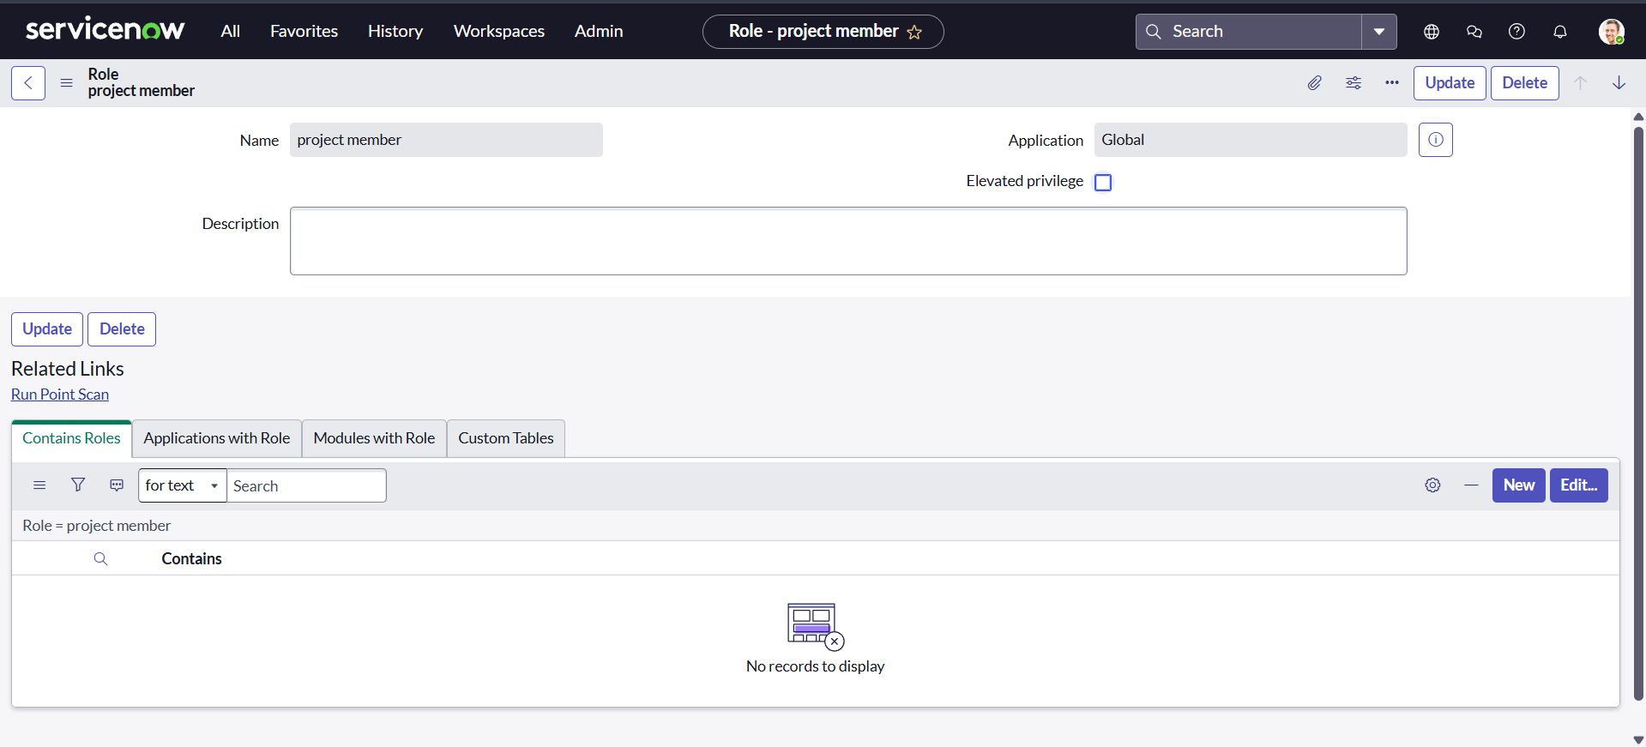

### **Milestone 4: Table**

#### **Activity 1: Create a Table**

1. Open ServiceNow.
2. Navigate to **All → Tables (under System Definition)**.
3. Click on **New**.
4. Fill in the details:
   * **Label:** Project Table
   * Enable **Create Module** & **Create Mobile Module**
   * Under **New Menu Name:** Project Table
   * Add necessary **Table Columns**
5. Click on **Submit**.
6. Create another table named **Task Table 2** with the required details and click **Submit**.

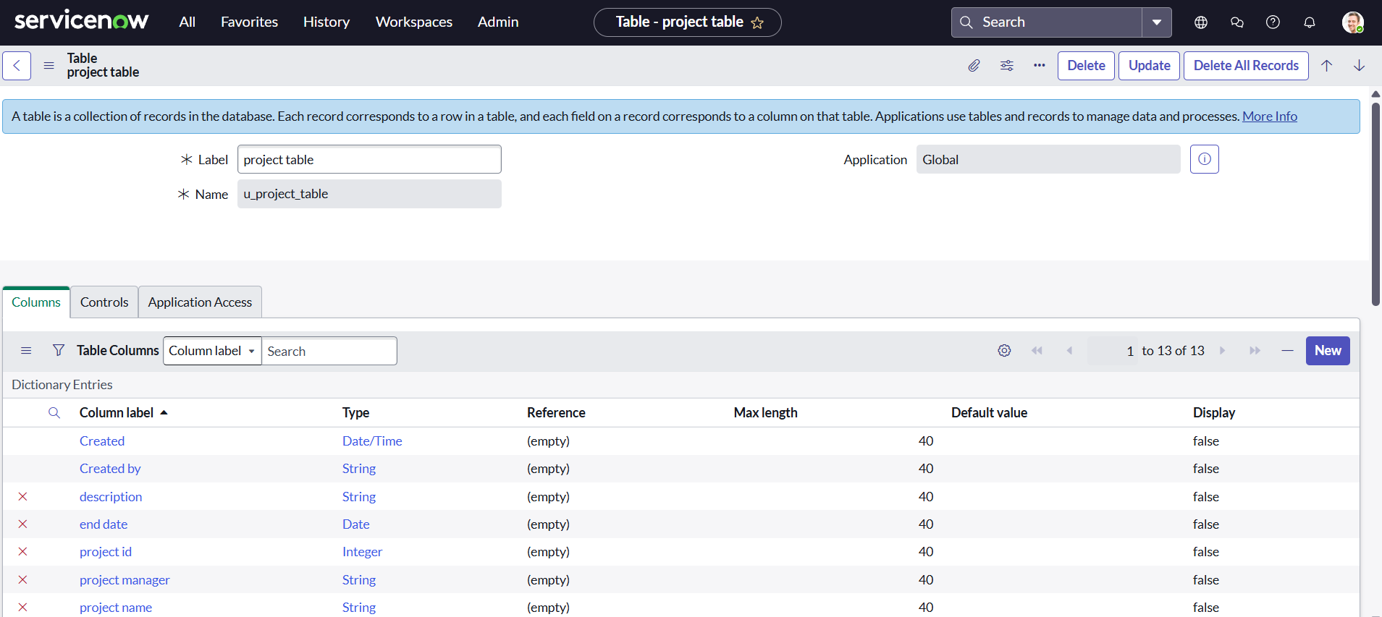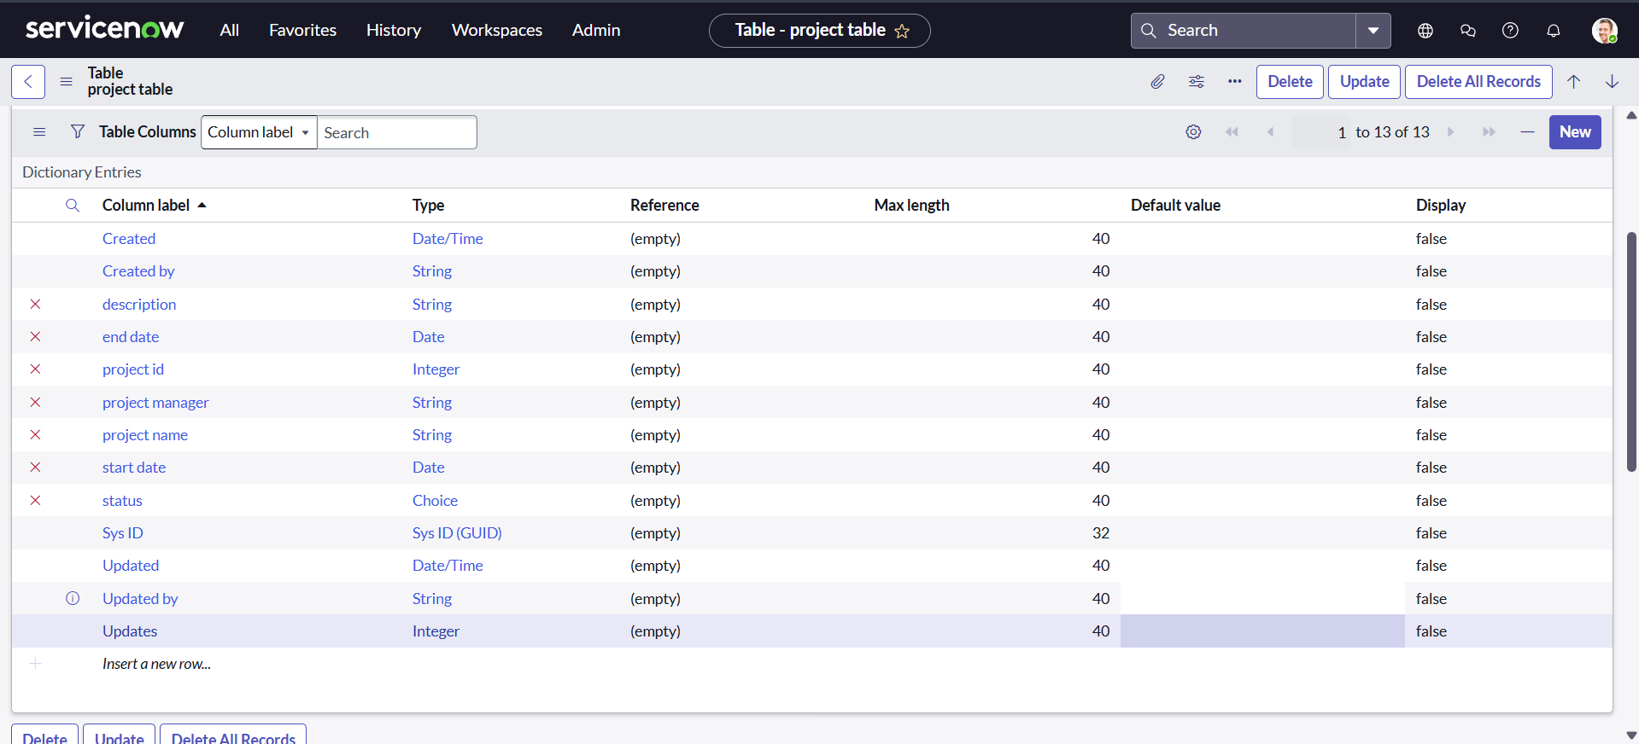

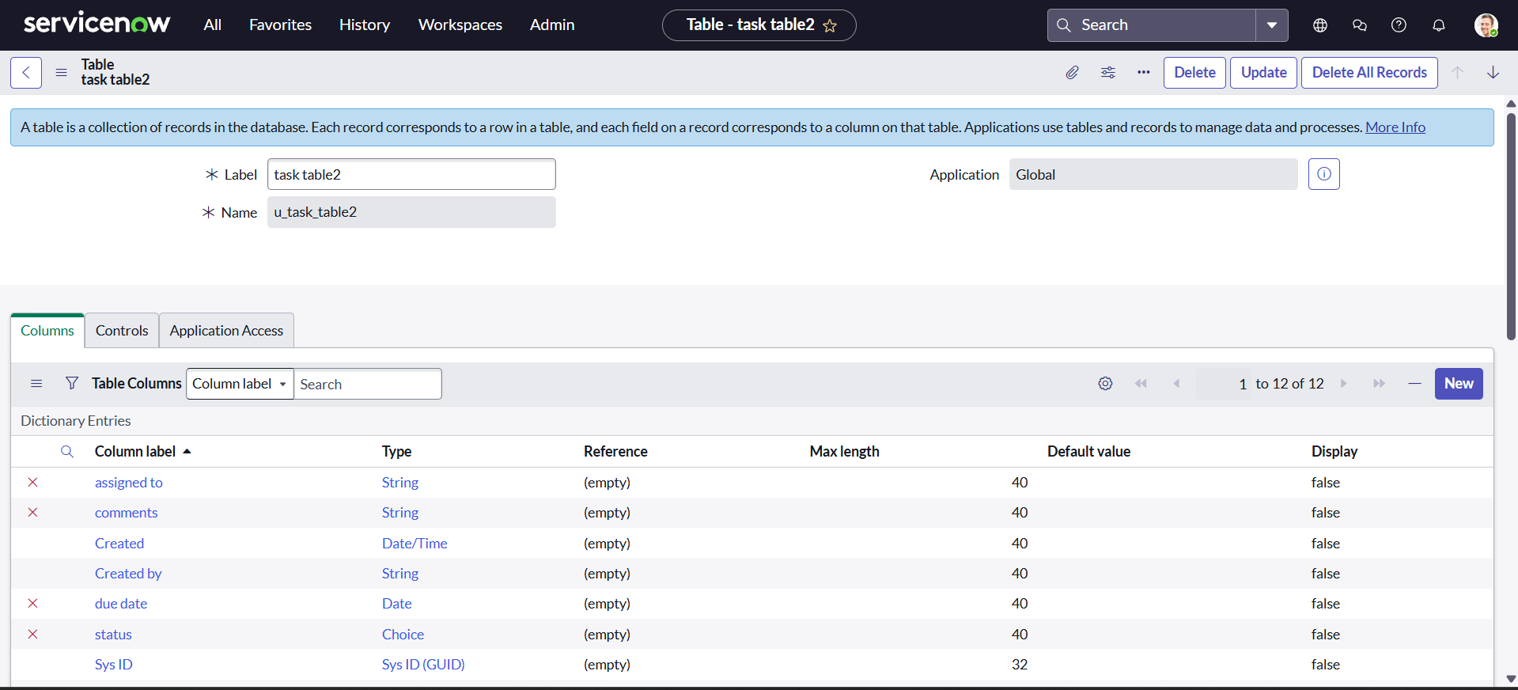

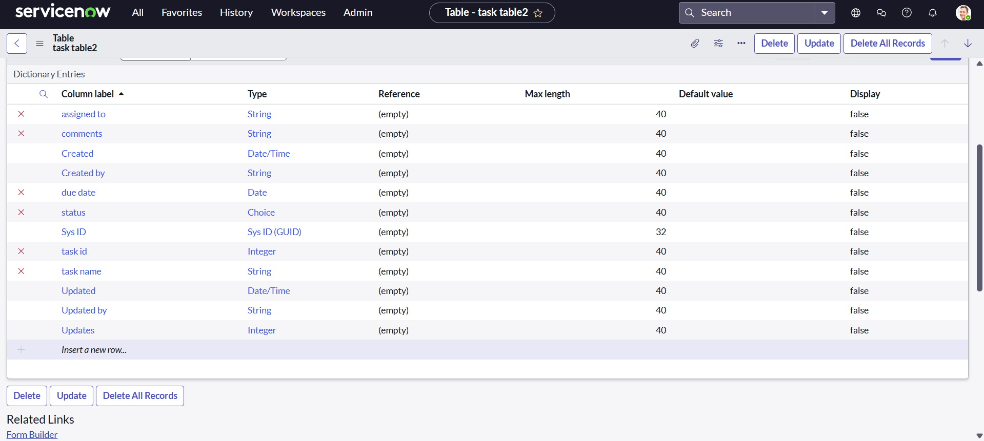

### **Milestone 5: Assign users to groups**

#### **Activity 1: Assign users to the project team group**

1. Open ServiceNow.
2. Navigate to **All → Groups**.
3. Select **Project Team Group**.
4. Under **Group Members**, click **Edit**.
5. Add **Alice P** and **Bob P** as group members and save.

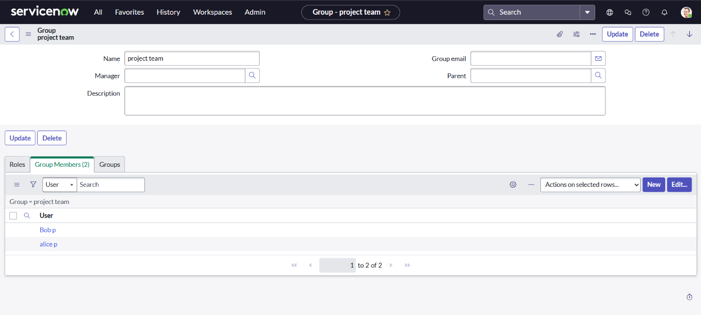

### **Milestone 6: Assign roles to users**

#### **Activity 1: Assign roles to the Alice user**

1. Open ServiceNow and search for **Users**.
2. Select **Project Manager user (Alice P)**.
3. Under **Roles**, click **Edit**.
4. Assign **Project Member**, **u_project_table**, and **u_task_table** roles.
5. Save and update the form.

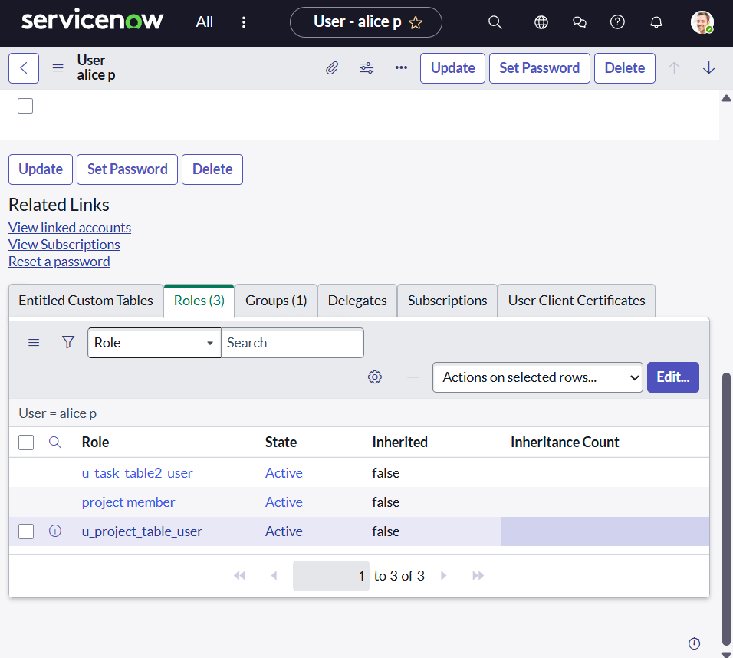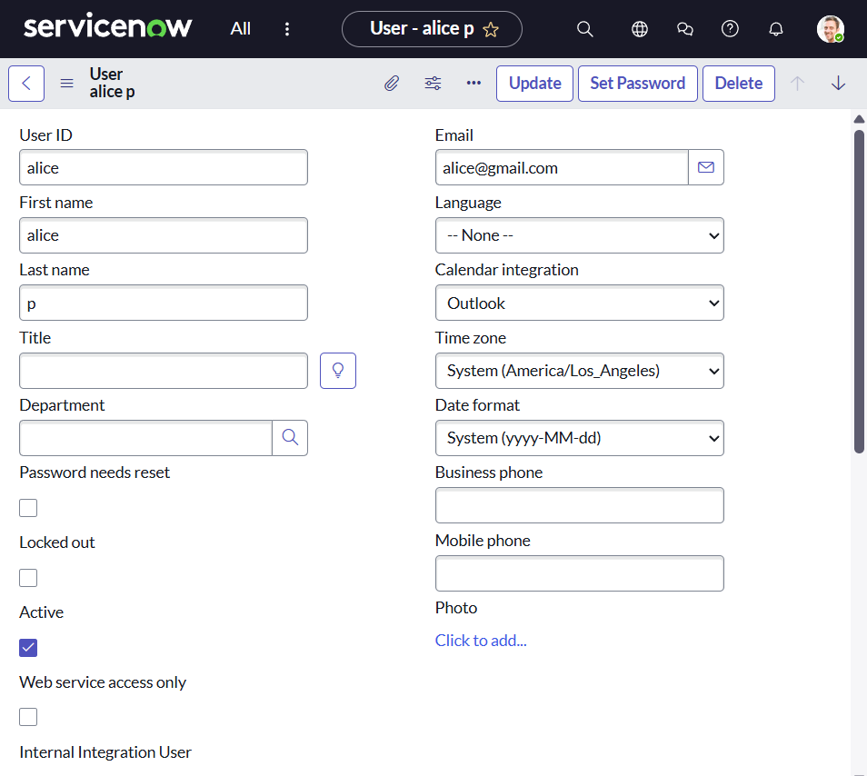

**Activity 2: Assign roles to the Bob user**

1. Open ServiceNow and search for **Users**.
2. Select **Team Member user (Bob P)**.
3. Under **Roles**, click **Edit**.

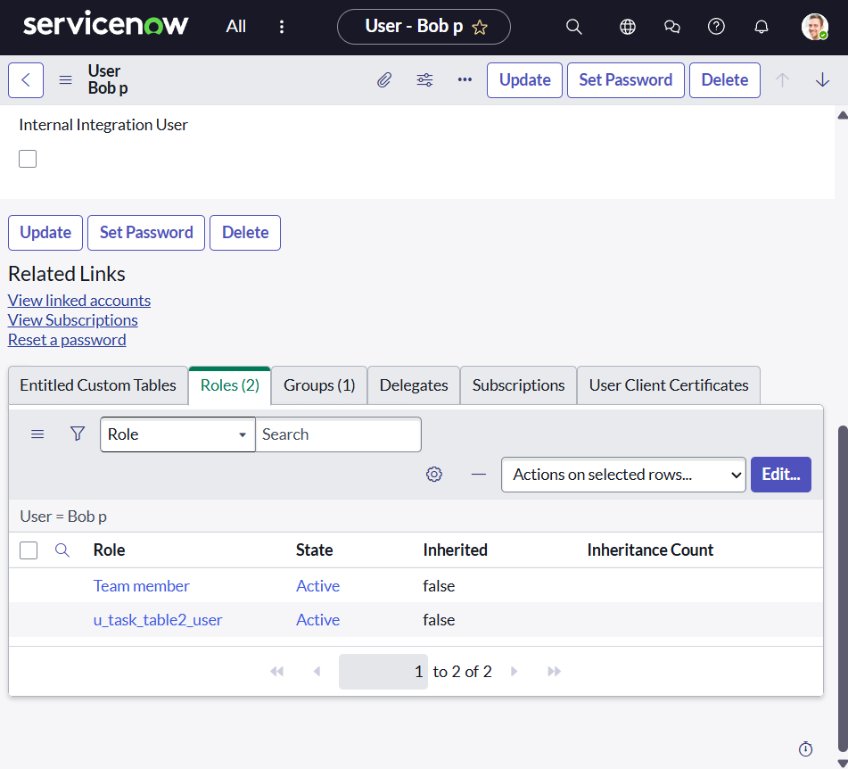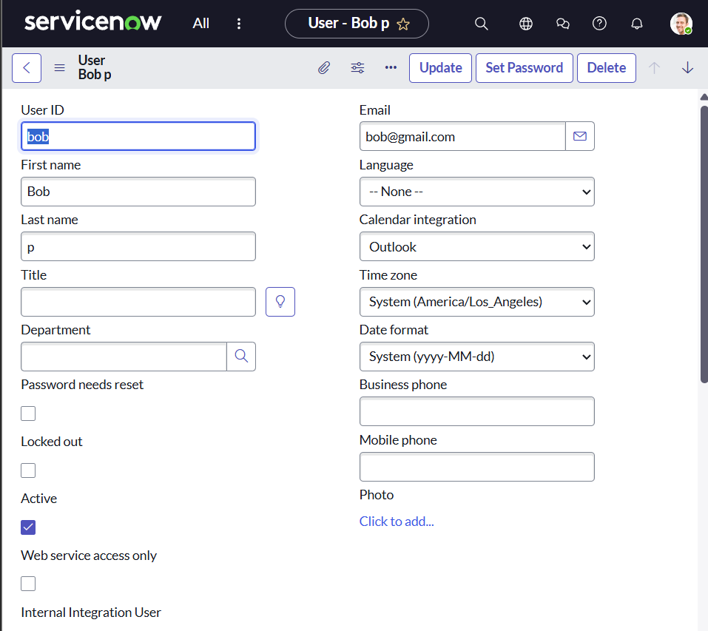

1. Assign **Team Member** role and appropriate table roles.
2. Save and update the form.
3. Impersonate Bob to verify that he has access to **Task Table 2**.

### **Milestone 7: Application access**

#### **Activity 1: Assign table access to the application**

1. When a table is created, an application and module are automatically created.
2. Navigate to the application in the Application Navigator.
3. 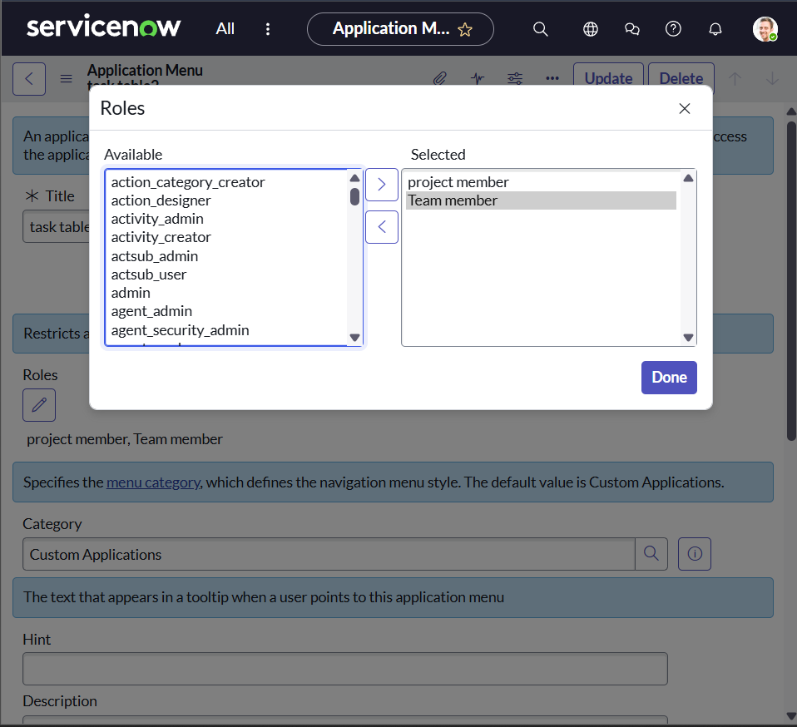Edit the module for the **Project Table** and assign the **Project Member** role.
4. Edit the module for **Task Table 2** and assign both **Project Member** and **Team Member** roles.

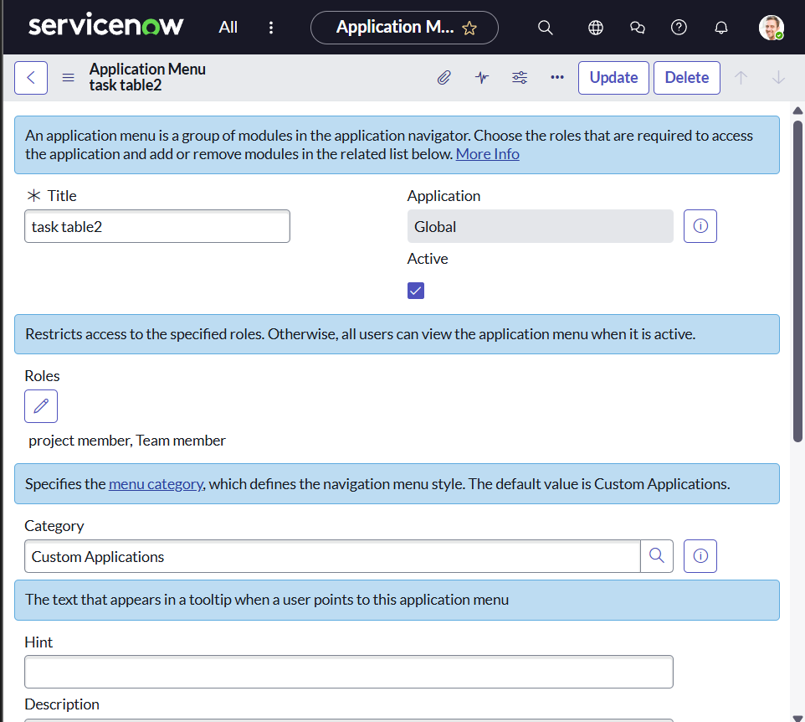

### **Milestone 8: Access control list**

#### **Activity 1: Create ACL**

1. Open ServiceNow.
2. Navigate to **All → Access Control (ACL) under System Security**.
3. Click on **Elevate Role** → **New**.
4. Fill in the ACL details.
5. Under **Requires Role**, add **Task Table** and **Team Member role**.
6. Submit

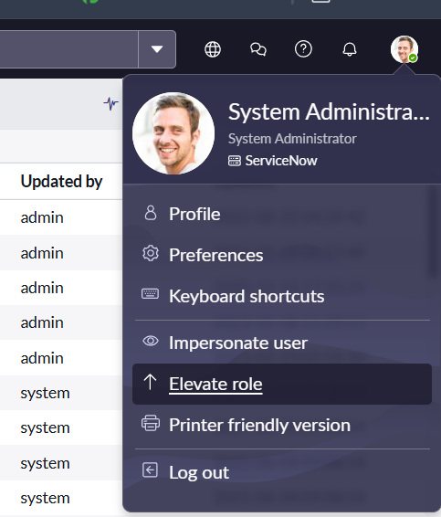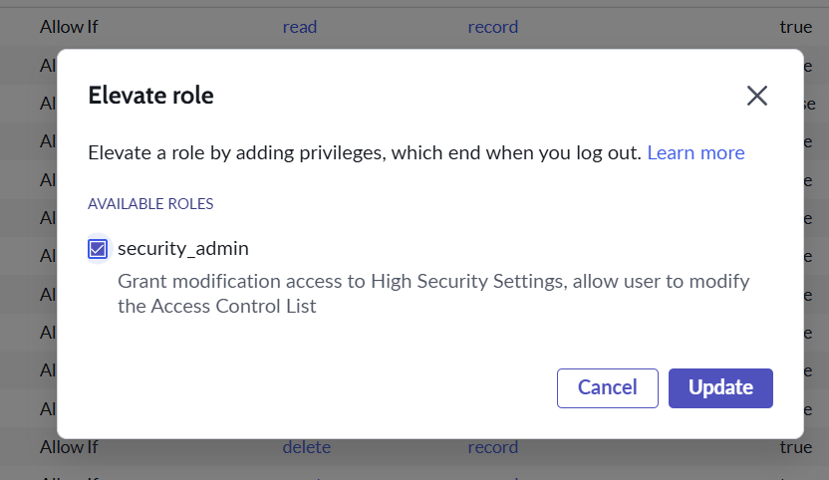

1. Similarly, create four ACLs for different fields.
2. **Verification:**
   * Impersonate Bob.
   * Navigate to **Task Table 2**.
   * Confirm that **Comment** and **Status** fields are editable.

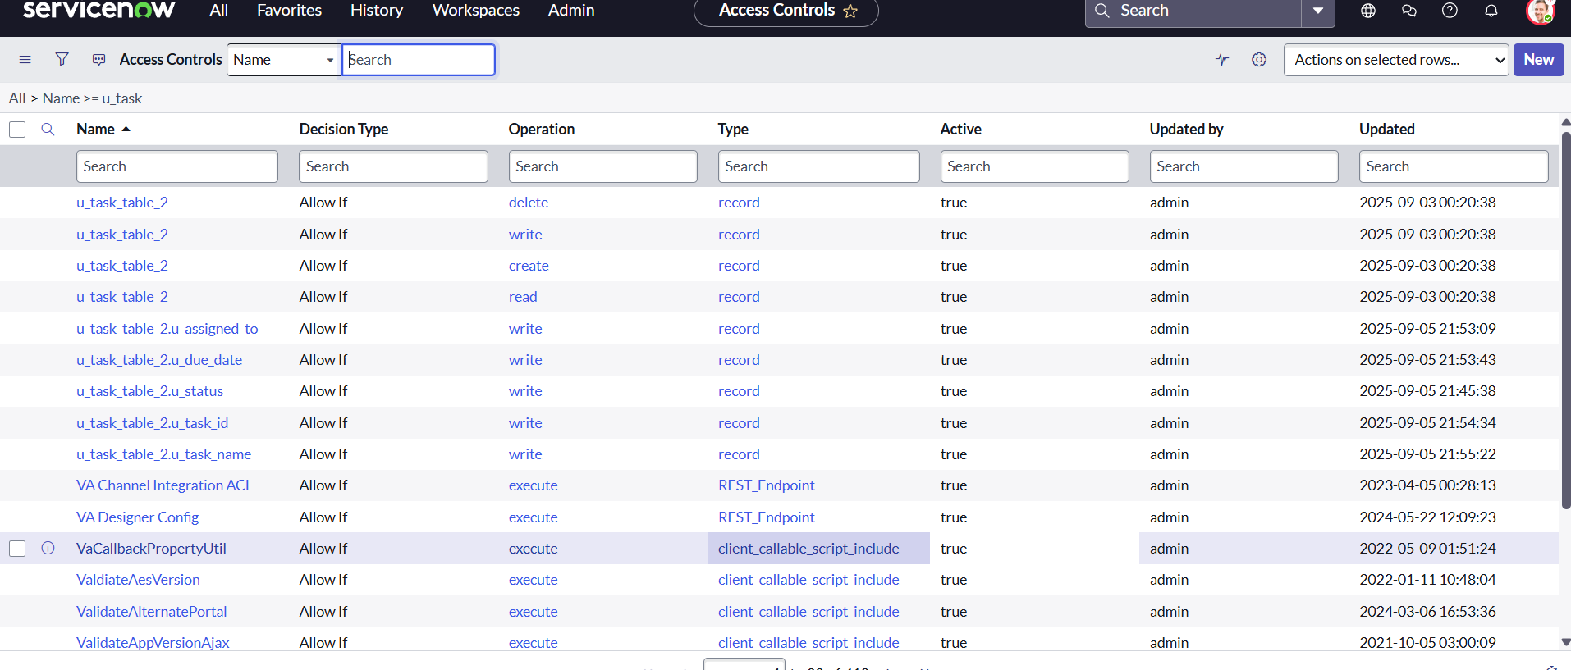

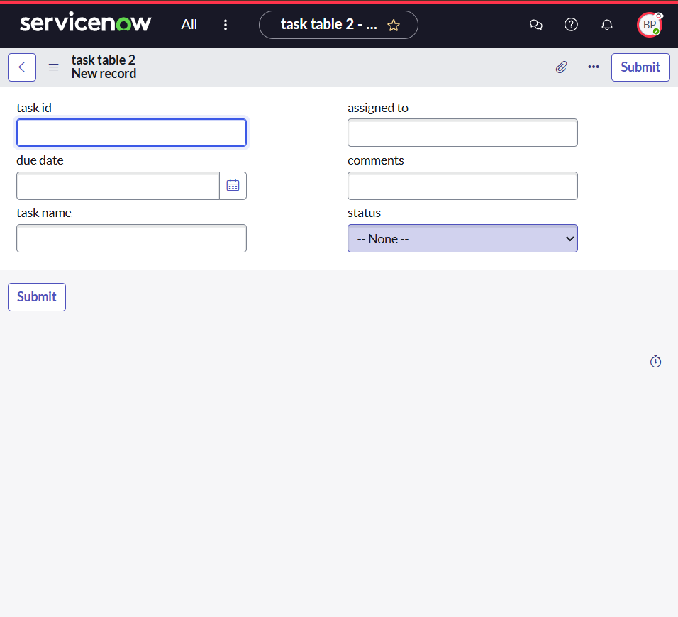

### **Milestone 9: Flow**

#### **Activity 1: Create a Flow to assign an operations ticket to a group**

1. Open ServiceNow.
2. Navigate to **All → Flow Designer (under Process Automation)**.
3. Click on **New Flow**.
4. Enter details:
   * **Flow Name:** Task Table
   * **Application:** Global

**Steps:**

* **Trigger:** Set trigger to *Record Created* on **Task Table** with conditions:
  + Status = In Progress
  + Comments = Feedback
  + Assigned To = Bob
* **Action 1:** *Update Records* → Set **Status = Completed**.
* **Action 2:** *Ask for Approval* → Assign approval to **Alice P**.

**Execution:**

* Bob updates the task → Status changes to *Completed*.
* Alice receives an approval request → Approves it.
* Task is successfully closed.

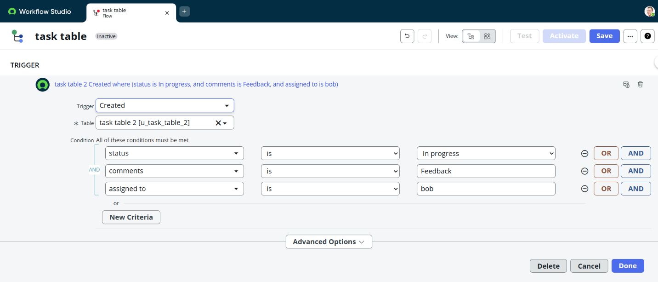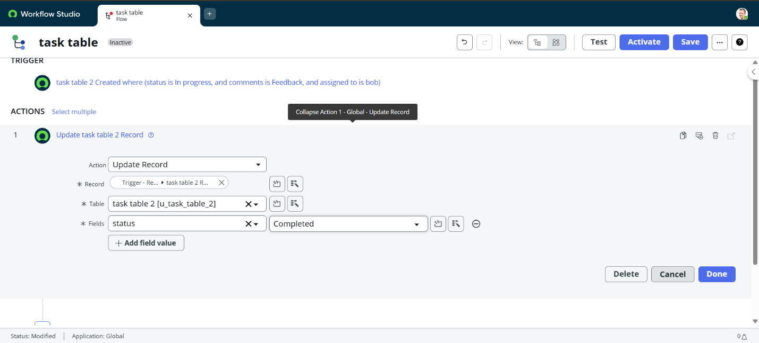

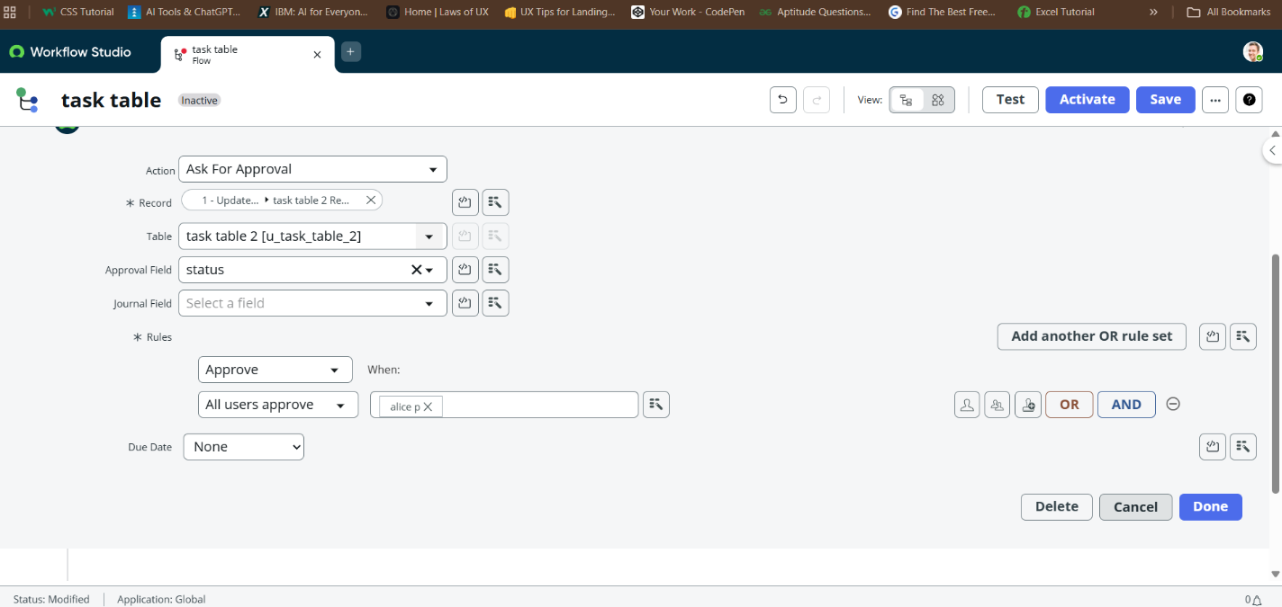

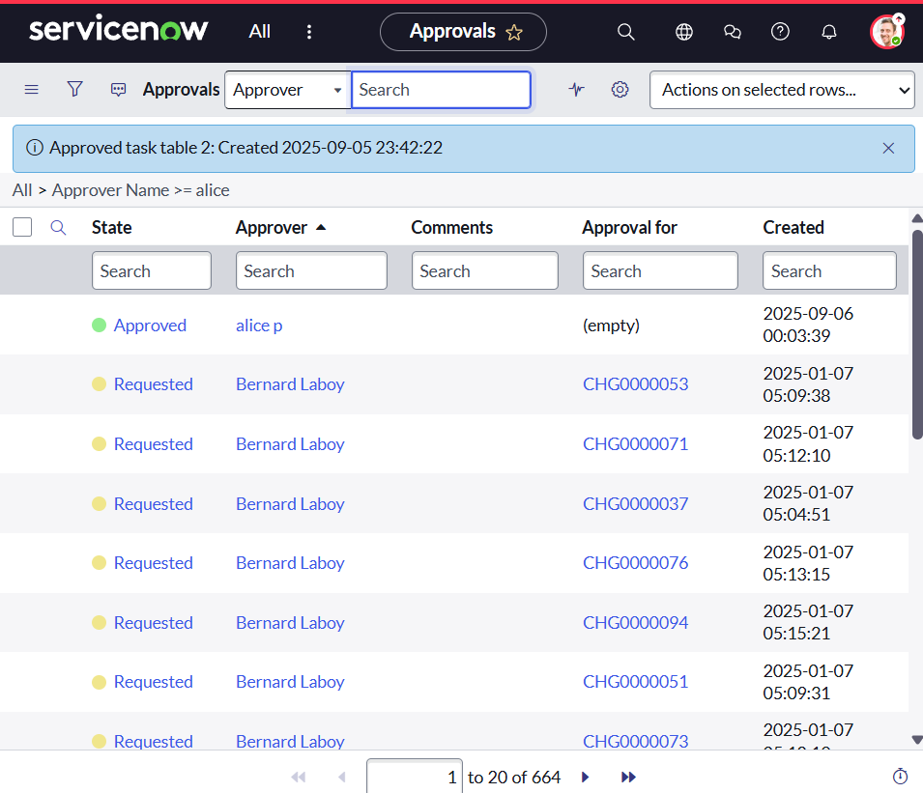

## **Conclusion**:

This scenario demonstrates a structured approach to project management by clearly defining roles and workflows. Alice, as the Project Manager, oversees task assignments and approvals, while Bob, as the Team Member, executes and updates tasks. The use of tables simplifies project tracking, and the integration of ACLs and workflows ensures accountability, transparency, and smooth communication. Overall, this system enhances project efficiency and leads to successful project completion.